

Objectives

Illustrate the use of GMS for analytic modeling with MODAEM.

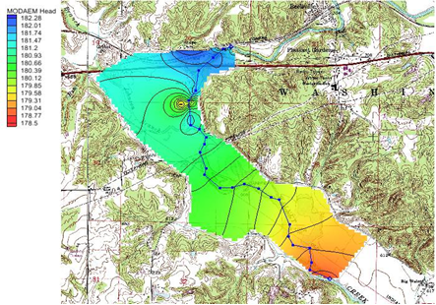

GMS 10.9

GMS 10.9 Tutorial

***MODAEM***

Analytic element modeling with MODAEM

Time

* 25–40 minutes

Required Components

* GMS Core
* MODAEM

Prerequisite Tutorials

* Feature Objects

|  |
| --- |
| 1 Introduction 2  1.1 Description of Problem 2  1.2 Getting Started 3  2 Setting up the Model 3  2.1 Importing the Background Map 3  2.2 Creating the Conceptual Model 4  2.3 Creating the Specified Head Arcs 5  2.4 Entering the Aquifer Properties 7  2.5 Saving the Project 7  2.6 Saving the Project 8  3 Creating the River 8  3.1 Running MODAEM 9  4 Adding Recharge 10  4.1 Running MODAEM 10  5 Wells 10  5.1 Production Wells 10  5.2 Observation Wells 11  5.3 Running MODAEM 11  6 Conclusion 12 |

# Introduction

MODAEM is a single-layer, steady-state analytic element groundwater flow model that has been enhanced for use with GMS. This tutorial introduces MODAEM and illustrates the use of GMS for analytic element modeling. This tutorial does not go into detail in explaining the analytic element method. For a more detailed explanation of analytic element modeling and MODAEM, refer to the MODAEM Help manual.

This tutorial will go over importing a background map, creating a conceptual model and defining the parameters, and finally running MODAEM for different conditions.

## Description of Problem

This tutorial describes the use of GMS to model groundwater flow near the wellfield in Brazil, Indiana, USA. Brazil (population of about 8,100) operates a wellfield about five miles east of town, in the floodplain of Big Walnut Creek (see Figure 1). The objectives of this model are to do the following:

* Model the five-year capture zone for the well field for use in the Brazil wellhead protection effort.
* Examine the effects of the addition of a well to the wellfield.

The following figure shows the site location, along with the model boundaries. The wellfield is situated in the floodplain of Big Walnut Creek. The aquifer is composed of coarse gravel with an average hydraulic conductivity of 250 ft/d (60.9 m/d), deposited in a buried bedrock valley. Although the bedrock surrounding the valley is slightly permeable, it is not considered an important source of water. The thickness of the gravel aquifer in the valley varies from 10–80 feet (3.0–24.4 meters). At the wellfield, the ground elevation is roughly 600 feet (183 meters), and the aquifer is roughly 60 feet (18.3 meters) thick.



Figure Model boundary

## Getting Started

Do the following to get started:

1. If necessary, launch GMS.
2. If GMS is already running, select the *File |* **New** command to ensure that the program settings are restored to their default state.

# Setting up the Model

## Importing the Background Map

The first step to create the model is to import a background image of the site being modeled. Use the image as a guide while creating points, arcs, and polygons to define features of the model.

1. Click **Open**  to bring up the *Open* dialog.
2. Change the *Files of type* to “Images (*.tif;*.tiff;*.jpg;*.jpeg;*.png;*.sid;*.ecw)”.
3. Browse to the *modaem* directory for this tutorial and select “brazil_topo.tif”.
4. Click **Open** to import the image and exit the *Open* dialog.

The background map should appear similar to Figure 2. The units and project projection have been set to match the data in the image file. These units and projection will be used for the rest of the project.

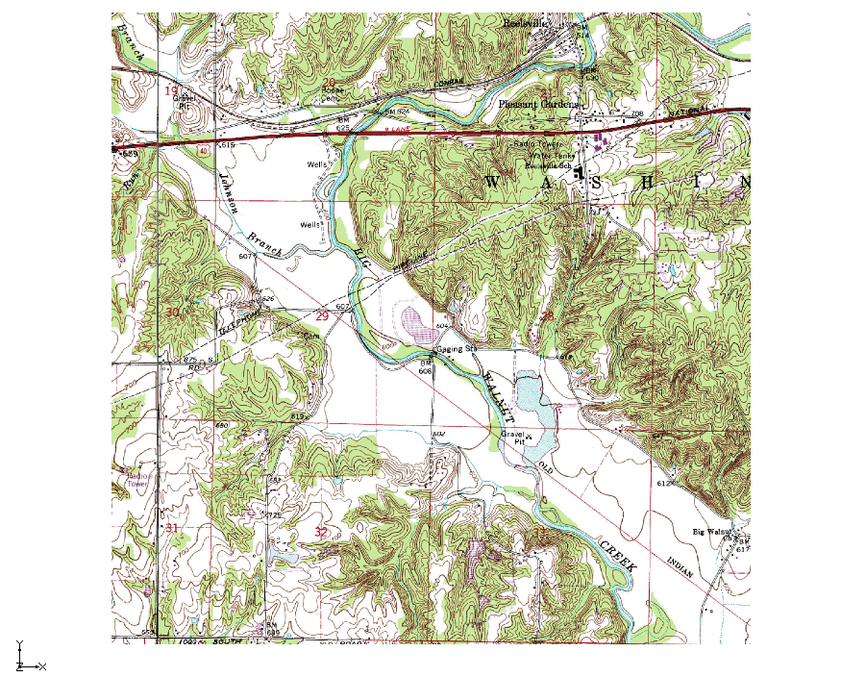

Figure Initial background map image

## Creating the Conceptual Model

It is now possible to enter the model data. First, create a MODAEM conceptual model. Second, create coverages to define the boundary conditions and aquifer properties. The boundary of the model is shown in Figure 3.

1. In the Project Explorer, right-click on the empty space and select *New |* **Conceptual Model…** to open the *Conceptual Model Properties* dialog.
2. Change the *Name* to “Indiana”.
3. Change the *Type* to “MODAEM”.
4. Click **OK** to close the *Conceptual Model Properties* dialog.
5. Right-click on “ Indiana” and select **New Coverage…** to open the *Coverage Setup* dialog.
6. Change the *Coverage name* to “Boundary”.
7. Select the *Use to define model boundary (active area)* option.
8. Click **OK** to close the *Coverage Setup* dialog.
9. Select “ Boundary” to make it active.
10. Using the **Create Arc**  tool, click out the boundary as shown in Figure 3 below.

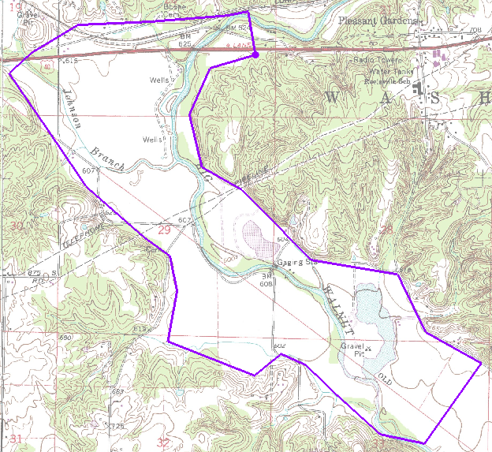

Figure Boundary arcs

## Creating the Specified Head Arcs

By default, the arcs in a MODAEM boundary coverage are “no flow” boundaries. This means the arc’s type is set to “specified flow” and that the flow is set to zero. Next, add specified head arcs to this coverage. To create the specified head arcs, split the boundary arc into four separate arcs.

### Convert Vertices to Nodes

1. Click **Display Options**  to open the *Display Options* dialog.
2. Select “Map Data” from the list on the left.
3. Under the *Map* tab, turn on *Vertices*.
4. Click **OK** to close the *Display Options* dialog.
5. Using the **Select Objects**  tool while pressing the *Shift* key, select the four points (vertices and/or nodes) indicated in Figure 4.

Depending on how the boundary arc was created, one of the vertices shown in Figure 4 may actually be a node. In that case, the node can still be selected with the **Select Vertex** tool (though it is not necessary in this case).

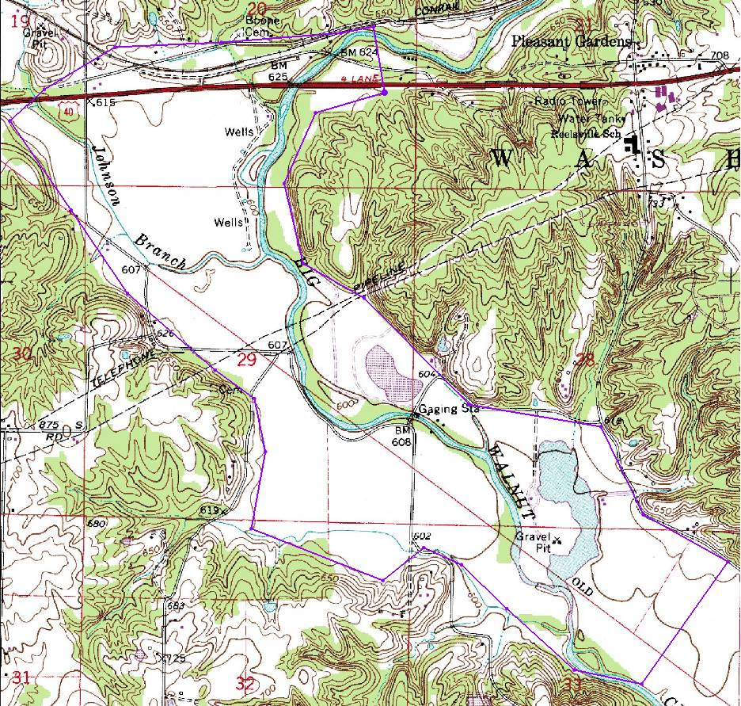

Figure Convert vertices to nodes

It may be necessary to insert additional vertices. This can be done by using the **Create Vertex**  tool. Simply select the tool and then click on the arc in the desired location.

1. Select *Feature Objects |* **Vertices** → **Nodes** to convert all the selected vertices to nodes.

### Assigning Arcs

1. Using the **Select Arcs**  tool while pressing the *Shift* key, select the two new arcs that were created on the north and south of the boundary (Figure 5).
2. Click the **Properties**  macro to open the *Attribute Table* dialog.
3. In the *All* row, change the *Type* to “spec. head” using the drop-down.
4. Click **OK** to exit the *Attributes Table* dialog.
5. Using the **Select Points/Nodes**  tool while pressing the *Shift* key, select both nodes on the northern specified head arc.
6. Click the **Properties**  macro to open the *Attribute Table* dialog.
7. Select “spec. head” from the *BC type* drop-down.
8. On the *All* row in the *Head (m)* column, enter “182.0”.
9. Click **OK** to exit the *Attributes Table* dialog.
10. Repeat steps 5–9 for the nodes attached to the southern specified head arc, but enter “178.6” for the *Head (m)* value.
11. Click **OK** to exit the *Attributes Table* dialog.

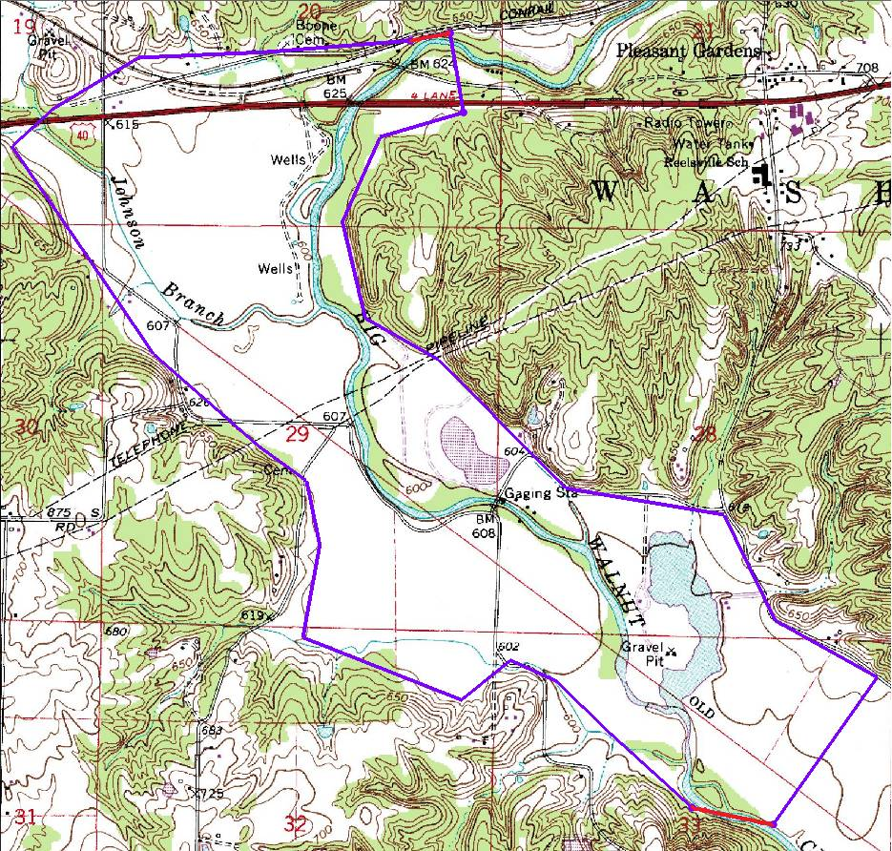

Figure Specified head arcs

## Entering the Aquifer Properties

Next, enter the properties of the aquifer as described in the following steps. Aquifer properties can be assigned to individual polygons and define properties for a background aquifer.

1. Select *MODAEM |* **Global Options…** to open the *MODAEM Global Options* dialog.
2. In the *Background aquifer properties* section, enter “170.0” as the *Base (m).*
3. Enter “18.0” as the *Thickness (m).*
4. Enter “60.0” as the *Hyd. cond. (m/d).*
5. Click **OK** to exit the *MODAEM Global Options* dialog.

With a boundary coverage, a single polygon must define the aquifer being modeled.

1. Select *Feature Objects |* **Build Polygons**.

## Saving the Project

It is now possible to run MODAEM. With other models in GMS, such as MODFLOW, it is required to save the changes to the project before running the model. Because MODAEM writes the data currently in memory to temporary files used to complete the model run, saving the changes in GMS before running MODAEM is not required. However, it is highly recommended to periodically **Save**  projects.

1. Select *File* | **Save As…** to open the *Save As* dialog.
2. Enter “brazil.gpr” as the *File name* and click **Save** to exit the *Save As* dialog.
3. If a prompt appears asking to replace a current “brazil.gpr” file, select **Yes**.

## Saving the Project

Selecting the menu command *MODAEM |* **Solve** will initiate a MODAEM run. Once this command is executed, a dialog will appear showing the output from the MODAEM model.

1. Select *MODAEM |* **Solve** to launch the *MODAEM* model wrapper dialog.
2. When *MODAEM* is finished, click **Close** to exit the *MODAEM* model wrapper dialog.

Head contours should now appear inside the boundary coverage.

1. Click **Contours** to open the *Dataset Contour Options – Map – MODAEM Head* dialog.
2. In the *Contour method* section, select “Color Fill and Linear” from the first drop-down.
3. Change the *Transparency* value to “60”.
4. Click **OK** to close the *Dataset Contour Options – Map – MODAEM Head* dialog.

# Creating the River

Now to add the river to the model:

1. Right-click on “ Indiana” in the Project Explorer and select **New Coverage…** to open the *Coverage Setup* dialog.
2. Enter “River” as the *Coverage name*.
3. In the *Source/Sink/BCs* section, turn on *River*.
4. Click **OK** to exit the *Coverage Setup* dialog.
5. Select the **CreateArc**  tool and click out the river arc starting near the northern specified head boundary and ending near the southern specified head boundary, as shown in Figure 6 below. Don’t extend the river beyond the boundary coverage.

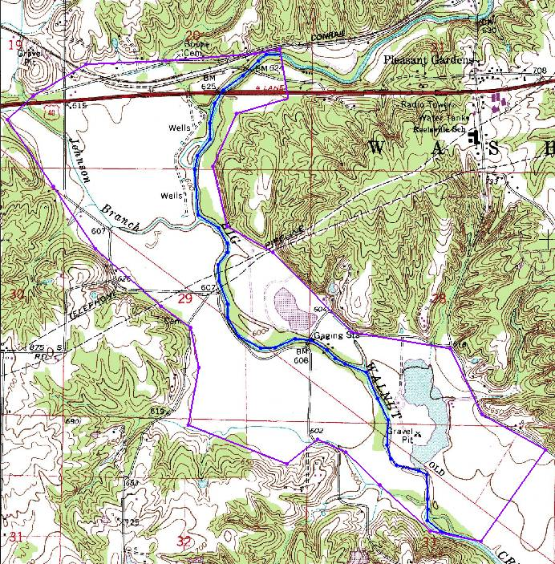

Figure Modeling the river

1. Using the **Select Arcs**  tool, double-click on the river arc to open the *Attribute Table* dialog.
2. In the *Type* column of the spreadsheet, select “river” from the drop-down.
3. Enter “5000.0” in the *Cond. (m/d)* column.
4. Click **OK** to close the *Attributes Table* dialog.
5. Using the **Select Points/Nodes**  tool, double-click on the river node at the northern end of the model to open the *Attribute Table* dialog.
6. Enter “182.0” as the *Head (m).*
7. Enter “179.0” as the *Elev. (m).*
8. Click **OK** to exit the *Attribute Table* dialog.
9. Repeat steps 10–13 for the southern river node but enter “178.6” for the *Head* and “175.6” for the *Elev. (m)*.
10. Click **OK** to exit the *Attribute Table* dialog.

## Running MODAEM

It is now possible to run MODAEM again.

1. Click the **Frame**  macro to see the entire model.
2. Select *MODAEM |* **Solve** to launch the *MODAEM* model wrapper dialog.
3. When *MODAEM* is finished, click **Close** to exit the *MODAEM* model wrapper dialog.

Notice some change in the head contours, particularly around the river arc.

MODAEM only calculates for the view that is currently visible in the Graphics Window. Zooming in before running MODAEM increases the refinement of the contours that MODAEM calculates. Zooming out decreases the contour refinement.

For example, if the view was zoomed in to select the southern river node, then the contours are highly refined, but only a small portion of the model results display.

By framing the model before running the simulation, MODAEM is able to calculate the entire boundary.

# Adding Recharge

Now to add recharge to the model:

1. Right-click on the “ Boundary” coverage and select the **Duplicate** command.
2. Double-click on “ Copy of Boundary” to bring up the *Coverage Setup* dialog.
3. Change the *Coverage Name* to “recharge”.
4. In the *Sources/Sinks/BCs* section, turn off *Specified Head* and *Specified Flow*.
5. In the *Areal Properties* section, turn on *Recharge*.
6. Click **OK** to exit the *Coverage Setup* dialog.
7. Using the **Select Polygons** 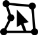 tool, double-click on the polygon to open the *Attribute Table* dialog.
8. Enter “0.00042” as the *Recharge (m/d)*.
9. Click **OK** to exit the *Attribute Table* dialog.

## Running MODAEM

It is now possible to run MODAEM again.

1. Select *MODAEM |* **Solve** to launch the *MODAEM* model wrapper dialog.
2. When *MODAEM* is finished, click **Close** to exit the *MODAEM* model wrapper dialog.

Notice some change in the head contours.

# Wells

## Production Wells

Now to import production wells from a tab-delimited text file:

1. Right-click on “ Indiana” and select **New Coverage…** to open the *Coverage Setup* dialog.
2. Change the *Coverage name* to “Wells”.
3. Under the *Source/Sink/BCs* section, turn on the *Wells* option.
4. Click **OK** to exit the *Coverage Setup* dialog.
5. Click **Open**  to bring up the *Open* dialog.
6. Select “All Files (*.*)” from the *Files of type* drop-down.
7. Select “prod_wells.txt” and click **Open** to exit the *Open* dialog and open the *Step 1 of 2* page of the *Text Import Wizard* dialog.
8. Below the first section, turn on *Heading row*.
9. Click **Next >** to go to the *Step 2 of 2* page of the *Text Import Wizard* dialog.
10. From the *GMS data type* drop-down, select “Well data”.
11. In the *File preview* section, select “X” from the *Type* drop-down in the first column.
12. Select “Y” from the *Type* drop-down in the second column.
13. Select “Flow Rate” from the *Type* drop-down in the third column.
14. Click **Finish** to exit the *Text Import Wizard* dialog.

There may be some difficulty in seeing the wells. If desired, the color of the well symbol can be changed in the *Display Options* dialog by clicking on the **Display Options**  macro and selecting the desired color for *Well* in the *Map* display options in the *Coverage* section.

## Observation Wells

Before running MODAEM again, import field-measured head values.

1. Right-click on “ Indiana” in the Project Explorer and select **New Coverage…** to open the *Coverage Setup* dialog.
2. Enter “Observation” as the *Coverage name*.
3. Under the *Observation Points* section, turn on the *Head* option.
4. Click **OK** to exit the *Coverage* *Setup* dialog.
5. Click **Open**  to bring up the *Open* dialog.
6. Select “well_head.txt” and click **Open** to exit the *Open* dialog and bring up the *Step 1 of 2* page of the *Text Import Wizard* dialog.
7. Below the first section, turn on *Heading row*.
8. Click **Next >**to go to the *Step 2 of 2* page of the *Text Import Wizard*.
9. Select “Observation data” from the *GMS data type* drop-down.
10. In the *File preview* section, select “Name” from the *Type* drop-down in the first column.
11. Select “X” from the *Type* drop-down in the second column.
12. Select “Y” from the *Type* drop-down of the third column.
13. Select “Obs. Head” from the *Type* drop-down of the fourth column.
14. Click **Finish** to exit the *Text Import Wizard* dialog.

The observation targets should appear.

## Running MODAEM

Now to run MODAEM again:

1. Select *MODAEM |* **Solve** to launch the *MODAEM* model wrapper dialog.
2. When *MODAEM* is finished, click **Close** to exit the *MODAEM* model wrapper dialog.

The project should appear similar to Figure 7.

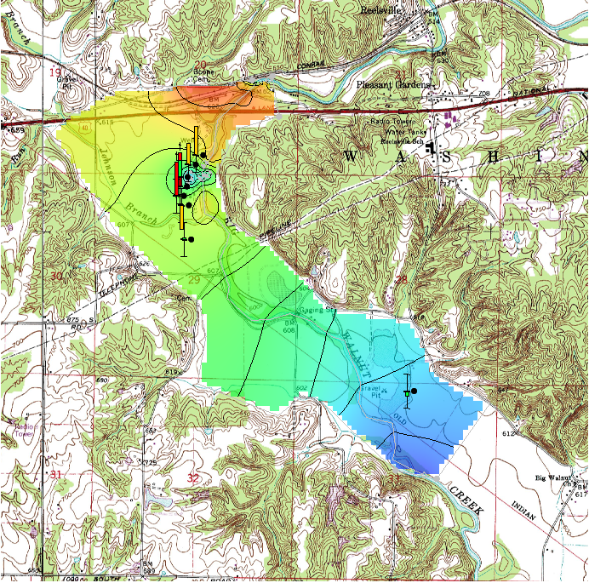

Figure Final MODAEM run

# Conclusion

This concludes the “MODAEM”tutorial. The following key concepts were discussed and demonstrated:

* MODAEM is an analytic element model that uses points, arcs, and polygons to compute solutions.
* The Map module is used to construct conceptual models using feature objects (points, arcs and polygons).

Feature objects are grouped into coverages. Only one coverage can be active, and only the active coverage can be edited.